Composite Attribute

🌟 Definition
# Source: AI Source: Provided by: [Data Path: Persons Table -> ID Column: 1, Name_En Column: Motasem Essam] -> From: [ChatGPT] on [6/10/2026]
A Composite Attribute is an attribute that can be divided into smaller meaningful sub-attributes.
Instead of storing one indivisible value, a composite attribute contains multiple related pieces of information.

🎯 Purpose
# Source: AI Source: Provided by: [Data Path: Persons Table -> ID Column: 1, Name_En Column: Motasem Essam] -> From: [ChatGPT] on [6/10/2026]
Composite attributes are used when:
- An attribute contains multiple components
- Individual parts need to be stored or accessed separately
- More detailed data organization is required

🧠 Simple Example
# Source: AI Source: Provided by: [Data Path: Persons Table -> ID Column: 1, Name_En Column: Motasem Essam] -> From: [ChatGPT] on [6/10/2026]
Composite Attribute
Full Name
Can be divided into:
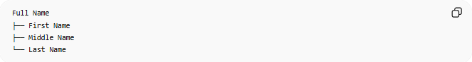
Full Name
├── First Name
├── Middle Name
└── Last Name

📚 Real-World Examples

1. Full Name
# Source: AI Source: Provided by: [Data Path: Persons Table -> ID Column: 1, Name_En Column: Motasem Essam] -> From: [ChatGPT] on [6/10/2026]
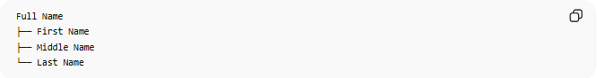
Full Name
├── First Name
├── Middle Name
└── Last Name
Example:
Ali Mohamed Hassan
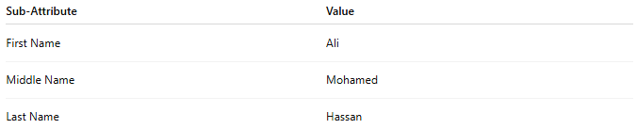
Sub-Attribute | Value
First Name | Ali
Middle Name | Mohamed
Last Name | Hassan

2. Address
# Source: AI Source: Provided by: [Data Path: Persons Table -> ID Column: 1, Name_En Column: Motasem Essam] -> From: [ChatGPT] on [6/10/2026]
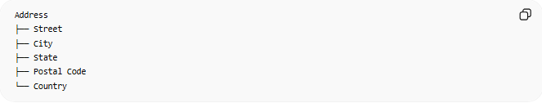
Address
├── Street
├── City
├── State
├── Postal Code
└── Country
Example:
123 Main St, Cairo, Egypt

3. Date
# Source: AI Source: Provided by: [Data Path: Persons Table -> ID Column: 1, Name_En Column: Motasem Essam] -> From: [ChatGPT] on [6/10/2026]

Date
├── Day
├── Month
└── Year
Example:
11 / 06 / 2026

🔢 Characteristics of a Composite Attribute
# Source: AI Source: Provided by: [Data Path: Persons Table -> ID Column: 1, Name_En Column: Motasem Essam] -> From: [ChatGPT] on [6/10/2026]
A composite attribute:
- Contains multiple components
- Can be broken into meaningful parts
- Improves data organization
- May be stored as separate columns in a database

📊 ER Diagram Representation
# Source: AI Source: Provided by: [Data Path: Persons Table -> ID Column: 1, Name_En Column: Motasem Essam] -> From: [ChatGPT] on [6/10/2026]
Customer Entity
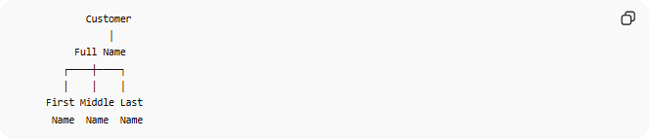
Customer
│
Full Name
┌────┼────┐
│ │ │
First Middle Last
Name Name Name

🗄️ Database Example
# Source: AI Source: Provided by: [Data Path: Persons Table -> ID Column: 1, Name_En Column: Motasem Essam] -> From: [ChatGPT] on [6/10/2026]
Conceptual Model
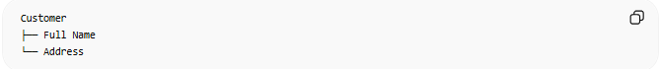
Customer
├── Full Name
└── Address
Relational Database
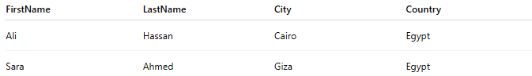
FirstName | LastName | City | Country
Ali | Hassan | Cairo | Egypt
Sara | Ahmed | Giza | Egypt
The composite attributes are usually split into separate columns.

🌍 Customer Example
# Source: AI Source: Provided by: [Data Path: Persons Table -> ID Column: 1, Name_En Column: Motasem Essam] -> From: [ChatGPT] on [6/10/2026]
Entity
Customer
Composite Attributes
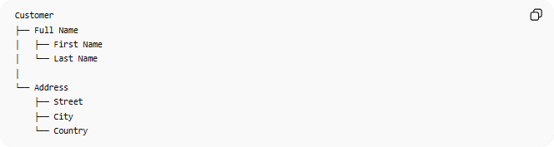
Customer
├── Full Name
│ ├── First Name
│ └── Last Name
│
└── Address
├── Street
├── City
└── Country

⚠️ Composite Attribute vs Simple Attribute
# Source: AI Source: Provided by: [Data Path: Persons Table -> ID Column: 1, Name_En Column: Motasem Essam] -> From: [ChatGPT] on [6/10/2026]
Simple Attribute
Age
Cannot be divided further.

Composite Attribute
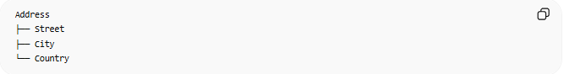
Address
├── Street
├── City
└── Country
Can be divided into smaller meaningful parts.

Comparison
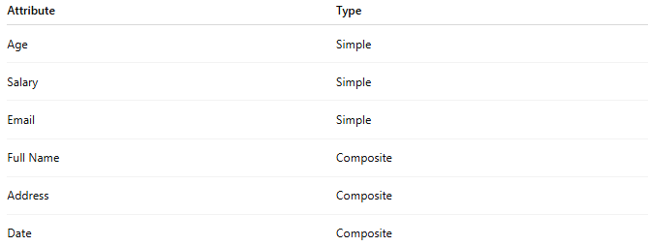
Attribute | Type
Age | Simple
Salary | Simple
Email | Simple
Full Name | Composite
Address | Composite
Date | Composite

📚 More Examples
# Source: AI Source: Provided by: [Data Path: Persons Table -> ID Column: 1, Name_En Column: Motasem Essam] -> From: [ChatGPT] on [6/10/2026]
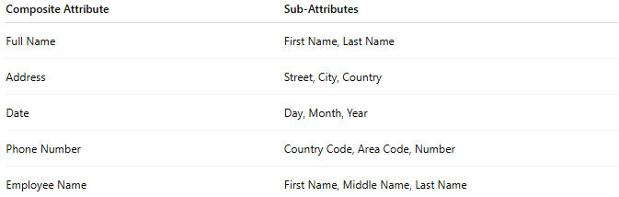
Composite Attribute | Sub-Attributes
Full Name | First Name, Last Name
Address | Street, City, Country
Date | Day, Month, Year
Phone Number | Country Code, Area Code, Number
Employee Name | First Name, Middle Name, Last Name

🧠 Simple Analogy
# Source: AI Source: Provided by: [Data Path: Persons Table -> ID Column: 1, Name_En Column: Motasem Essam] -> From: [ChatGPT] on [6/10/2026]
Think of an address written on an envelope:
123 Main St, Cairo, Egypt
This is one piece of information called Address, but it contains several smaller parts:
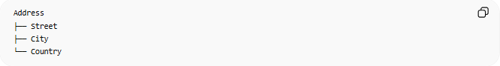
Address
├── Street
├── City
└── Country
Therefore, Address is a Composite Attribute.

🧭 Summary
# Source: AI Source: Provided by: [Data Path: Persons Table -> ID Column: 1, Name_En Column: Motasem Essam] -> From: [ChatGPT] on [6/10/2026]
A Composite Attribute is an attribute that can be divided into smaller meaningful sub-attributes. Examples include Full Name, Address, Date, and Phone Number. Composite attributes help organize and structure data more effectively in a data model.

